Contents
1 Introduction 4
1.1 Purpose and Scope 4
2 Design Overview 4
3 Detailed Design 5
3.1 RemCon Client APIs 5
3.1.1 Player Information API 6
3.1.2 Player Setting Resource Reader 8
3.1.3 Media Information API 9
3.1.4 Group Navigation API 11
3.1.5 Battery Status API 13
3.2 Target Selector Plugin 15
3.2.1 Overview 15
3.2.2 UML Diagram 16
3.2.3 Design Unit Behaviour 16
3.3 AVRCP bearer 18
3.3.1 Overview 18
3.3.2 UML Diagram 18
3.3.3 Design Unit Behaviour 18
3.4 RemCon Server 18
3.4.1 Overview 18
3.4.2 UML Diagram 20
3.4.3 Design Unit Behaviour 21
4 Use Cases 23
4.1 Single AVRCP 1.3 media player receives remote control command 23
4.2 Single AVRCP 1.3 media player registers for Notify Interface 24
4.3 Single AVRCP 1.3 media player and Interim response 24
4.4 Single AVRCP 1.3 media player and final response 25
4.5 Handover of notify 25
4.6 AVRCP 1.3 media player unregisters with outstanding Notify 26
5 Design Considerations 27
5.1 Compatibility 27
5.1.1 Exported Function Forwarding to Virtual Function 27
5.1.2 Interface Version Request 27
6 Further Information 28
6.1 References 28
6.2 Open Issues 28
6.3 Glossary 28
6.4 History 28
Appendix A - Draft APIs 29
A.1 Player Info API 29
A.1.1 playerinformationtarget.h 29
A.1.2 playerinformationtargetobserver.h 33
A.2 Media Info API 41
A.2.1 remconmediainformationtarget.h 41
A.2.2 remconmediainformationtargetobserver.h 43
A.3 Group Navigation API 44
A.3.1 remcongroupnavigationtarget.h 44
A.3.2 remcongroupnavigationtargetobserver.h 47
A.4 Battery Status API 48
A.4.1 remconbatterytarget.h 48
A.4.2 remconbatterytargetobserver.h 50
A.5 TSP API 51
A.5.1 remcontargetselectorplugininterface.h 51
A.5.2 remcontargetselectorpluginobserver.h 56

Introduction
The GT400 project introduces (amongst other things) Bluetooth Audio Video Remote Control Profile (AVRCP) 1.3 [R1] functionality. This is an extension to the original AVRCP, vesion 1.0. This document covers the design changes in both the AVRCP bearer and the RemCon system, and so should be read in conjunction with the standalone component design documents for these components.
The AVRCP is concerned with remote control over Bluetooth. All AVRCP data is contained within AV/C [R2] frames.
AVRCP 1.0 focused mainly on the exchange of basic remote control commands such as are found on a standalone remote control device, for example play and stop. In addition vendor dependant extensions are enabled. The AVRCP 1.3 specification uses the vendor dependant extension mechanism for the Metadata Transfer functionality. This is provided as a specified set of vendor dependant commands with the vendor being the Bluetooth SIG.

Purpose and Scope
This document provides a high level design description of the changes that are needed to enable AVRCP 1.3 functionality with the Remote Control Framework (RemCon).
The target audience for this document are team members on the GT400 project. At this point it is aiming to record details of the design under discussion whilst the project is under development. The document will need updating as implementation progresses, design decisions are made and the information in this document becomes out of date. This document will likely form the basis of a design document to accompany the output code for submission to the MCL.

Design Overview
The reader of this document should ensure some degree of familiarity with the existing RemCon framework [R4] and AVRCP bearer. Figure 1 Component Diagram shows a high level view of components and interfaces in the system. In the diagram items coloured white are new and items coloured blue are modified.

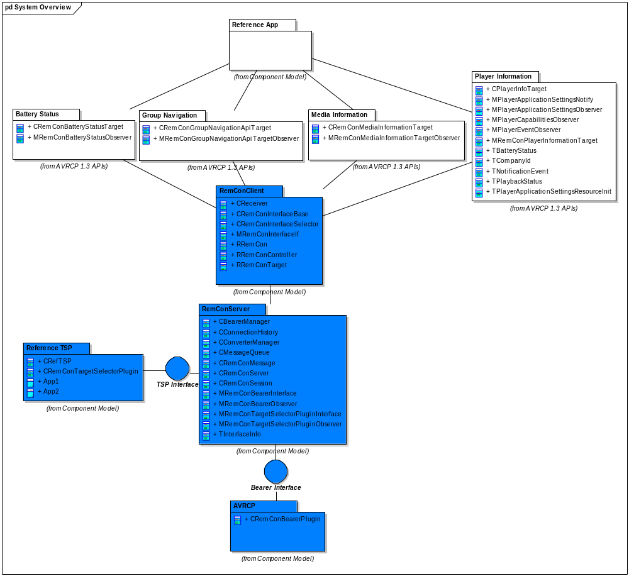
Figure 1 Component Diagram

Detailed Design

RemCon Client APIs
Multiple new client APIs will be necessary to convey all the commands contained within AVRCP 1.3. These will be provided in addition to the existing RemCon APIs. The split between APIs is show in Table 1 AVRCP 1.3 Commands by RemCon API. The fragmentation commands will not be supported in the client APIs. Fragmentation will be handled in the AVRCP bearer.
The InformDisplayableCharacterSet command will not be supported. This has the implication that all strings shall be in UTF-8.
PDU | Player Info API | Media Info API | Group Navigation API | Battery Status API
Capabilities
GetCapabilities | X
Player Application Settings
ListPlayerApplicationSettingAttributes | X
ListPlayerApplicationSettingValues | X
GetCurrentPlayerApplicationSettingValue | X
SetPlayerApplicationSettingValue | X
GetPlayerApplicationSettingAttributeText | X
GetPlayerApplicationSettingValueText | X
InformBatteryStatusOfCT |  |  |  | X
Metadata Attributes
GetElementAttributes |  | X
Notifications
GetPlayStatus | X
RegisterNotification | X
Basic Group Navigation
Next Group |  |  | X
Previous Group |  |  | X
Table 1 AVRCP 1.3 Commands by RemCon API

Player Information API

Overview
The Player Information API covers retrieving information about the Media Player. This falls into two main categories, information about the static menu structure of the player and information about the current status of the player. Because the current status of the player includes changes of the settings within the menu structure it is sensible to include all this information in one API.
This API requires that the target application pushes state information into the interface. This facilitates handling of multiple players, as the state and status changes of each player are always available.
It is likely that the static information is desired to be stored in a localisable resource file. For this reason a resource file utility is provided to retrieve attributes and values from a resource file in a defined format. This allows vendor defined menu extensions.

UML Diagram
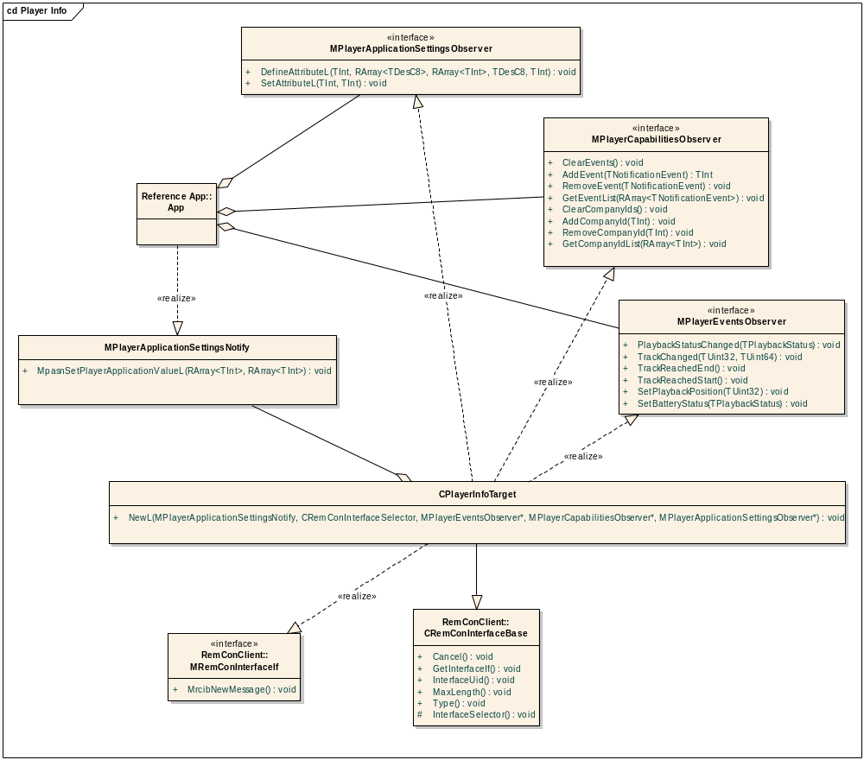
Figure 2 Player Information API

Design Unit Behaviour
The capabilities functionality is provided by three interfaces, MPlayerApplicationSettingsObserver, MPlayerCapabilitiesObserver and MPlayerEventsObserver. These are implemented by CPlayerInfoTarget, which is a RemCon interface. The functionality provided by the interfaces falls into three logical groups, hence the splitting into different interfaces. However, the functionality is not independent. One central point of control must deal with the interactions between the classes.
The three M classes use the exported function forwarding to virtual function pattern for BC purposes. For details of this pattern refer to 4.1.1.
In addition the client application must implement the MPlayerApplicationSettingsNotify interface. This allows the API to inform the client application when a remote controller has updated the value of a setting.

Player Application Settings
The Player Application Settings API is used to gather information about media player settings. This includes the static menu structure of the player, and the current values of the settings. There are two functions on this API, DefineAttributeL and SetAttributeL.
DefineAttributeL is used to set up an attribute for use. It provides a list of all defined values this attribute can take as well as textual descriptions for each of these values. An initial value is also provided. It is expected that this function is called at the time the application opens the CPlayerInfo interface. As the information contained here is usually statically known a utility function has been provided (see 3.1.2). This means that a media player may choose to not call this function directly, instead calling PlayerApplicationSettingsResourceInit::DefineAttributesL to perform attribute definition.
Once the attributes have been set up the application may call SetAttributeL to set the value of one of the previously defined attributes to one of the values provided when the attribute was defined.
To allow the remote device to set values of the player application settings the MPlayerApplicationSettingsNotify class is provided. When a value is updated remotely the MpasnSetPlayerApplicationValueL function is called. This provides the client application with a list of new attributes and values. Two arrays are provided. The first array contains attributes. The second array contains values for those attributes. The value at a certain index in the value array is for the attribute at the same index in the attribute array. So for example if the attribute id at index 3 was shuffle, then the value at index 3 would be for the shuffle attribute.

Player Capabilities
The Player Capabilities API is used to allow the application to register what capabilities it has. At the moment the available capabilities are the supported company IDs and supported notification events. The Bluetooth SIG company ID is assumed by default. However, additional company IDs can be provided if the application wishes to use any vendor defined behaviour. Functions on this API are provided to add, remove and view items on the supported company IDs and supported events lists.

Player Events
The Player Events API is provided to allow the application to inform RemCon of changes to its state.
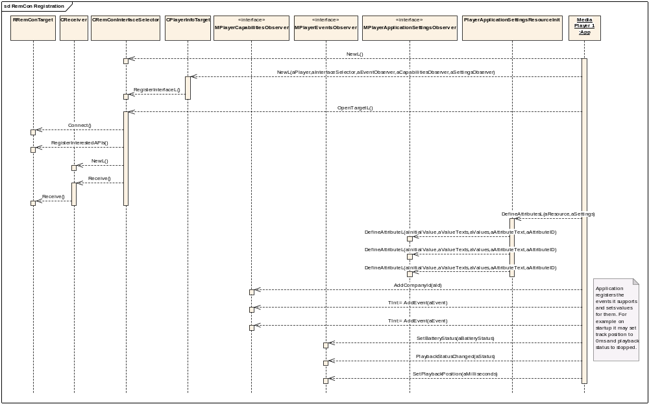
Figure 3 RemCon Registration

Player Setting Resource Reader
The main use case of this is for the Player Application Settings commands in AVRCP 1.3. These commands are used to retrieve static UI menu structure from the media player. It is likely that many controllers will quickly issue these commands immediately upon connection. At this point the default media player may not be loaded, so it may be useful to be able to return information that is statically known. This is because if the controller fails to retrieve the information upon connect it may not retry. By including this information in a resource file it is easily localisable by the application writer.

Overview
This is one static function which uses the provided CResourceFile to set up the provided MPlayerApplicationSettingsObserver.

UML Diagram
See Figure 2 Player Information API for how the TPlayerApplicationSettingsResourceInit fits into the class structure.

Design Unit Behaviour
The application provided resource file is in a defined format. This defines a set of attributes and their values. The function reads the information out of the resource file, interpreting the defined format to determine what the player application settings are, then using the functions on MPlayerApplicationSettingsObserver defines those attributes. This is shown in Figure 4 Defining attributes based on resource file.
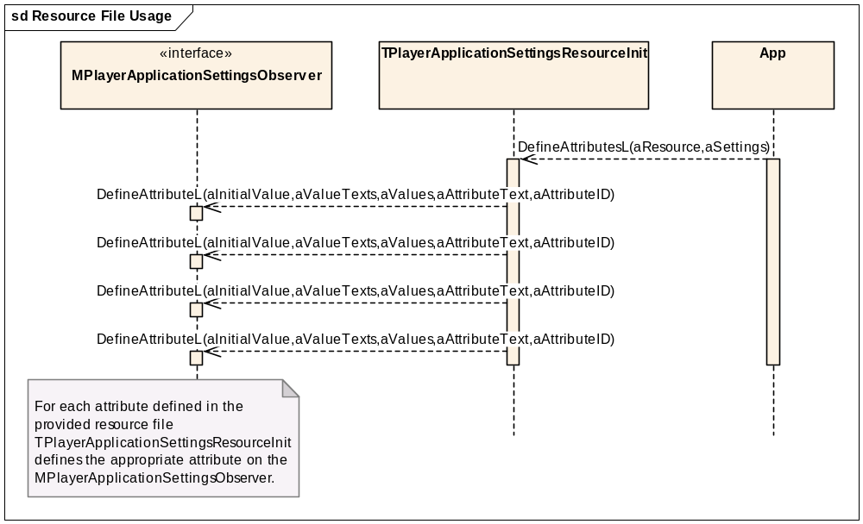
Figure 4 Defining attributes based on resource file

Media Information API

Overview
The Media Information API covers retrieving information about the currently playing media element. This is done in AVRCP via the GetElementAttributes command. This command can request a variable number of attributes about the media element, and the application may be able to provide some, all or none of the requested attributes.

UML Diagram
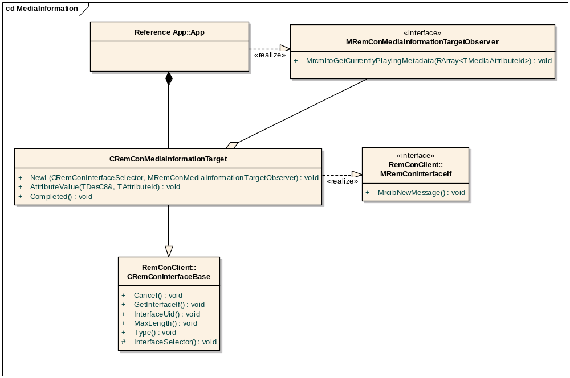
Figure 5 Media Information API

Design Unit Behaviour
The functionality is provided by a pair of classes, an M class implemented by the client application to allow information to be requested, and a C class, which the client application uses to feed that information back in.
An attributes request is passed via the MrcibNewMessage function from the interface selector to the interface. This request contains a variable number of attributes. The list of attributes for which values are requested are passed to the client application via the MrcmitoGetCurrentlyPlayingMetadata function. The client application should then call back to the interface using the AttributeValue function for each attribute for which it can obtain a value. Once it has provided all available values it calls the Completed function. Following this the interface packages all received attribute values and sends them back to RemCon via the interface selector. This sequence of events is illustrated in Figure 6 Use of Media Information API.
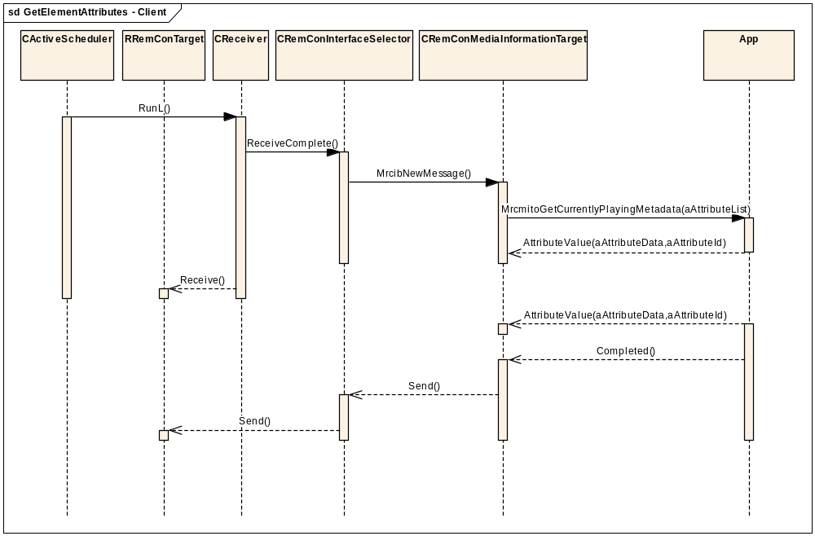
Figure 6 Use of Media Information API

Group Navigation API

Overview
The Group Navigation API covers the basic group navigation commands, Next Group and Previous Group. These are very simple PASSTHROUGH commands and this API is very similar in style to the way existing PASSTHROUGH commands are handled in the Core API.

UML Diagram
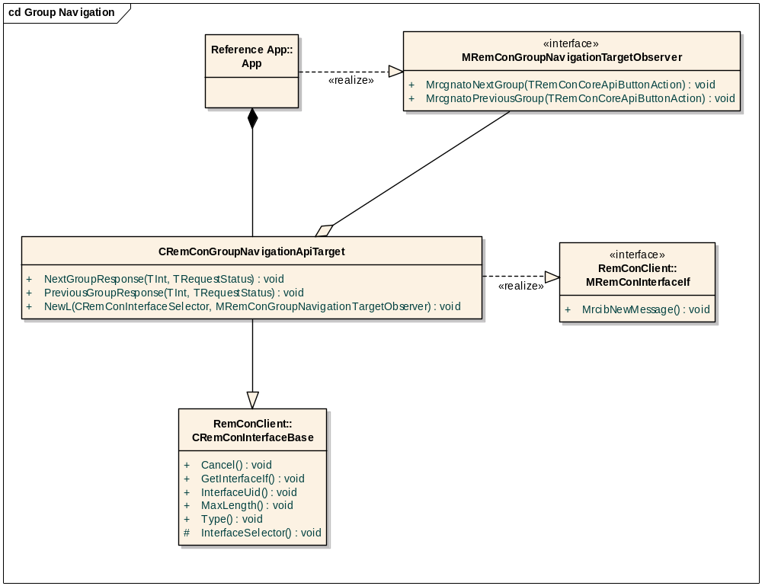
Figure 7 Group Navigation API

Design Unit Behaviour
Like other RemCon interfaces this consists of a pair of classes, an M class implemented by the client application used to inform the app of a new command, and the interface C class used to provide the responses. When the interface receives a command from RemCon via the MrcibNewMessage function it will examine the operation id of the command and call the appropriate function on the client application, either MrcgnatoNextGroup or MrcgnatoPreviousGroup. The client application should then respond via the corresponding response function on the interface class. The sequence for a NextGroup command is illustrated in Figure 8 Receiving Next Group Command.
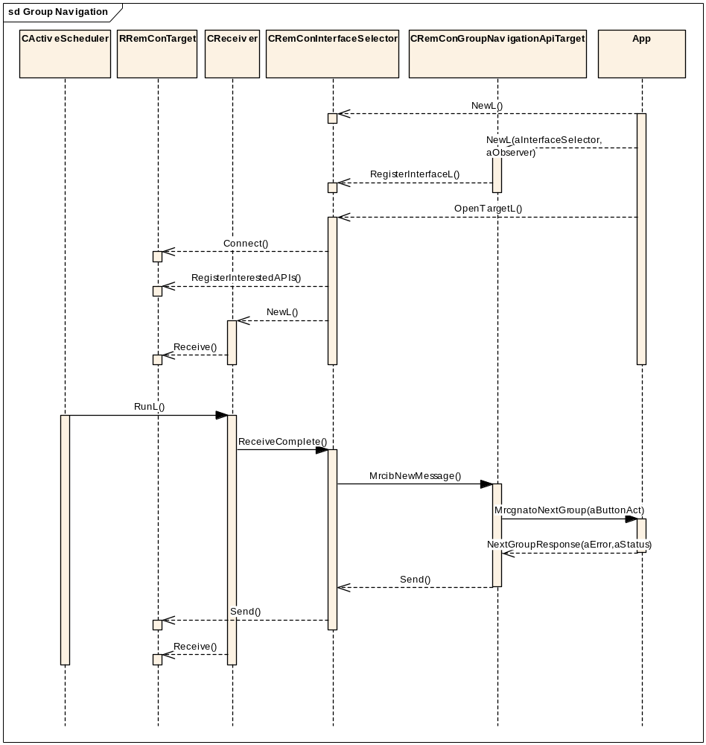
Figure 8 Receiving Next Group Command

Battery Status API

Overview
The Battery Status API is a very simple API solely for providing access to the battery status of the remote controller.

UML Diagram
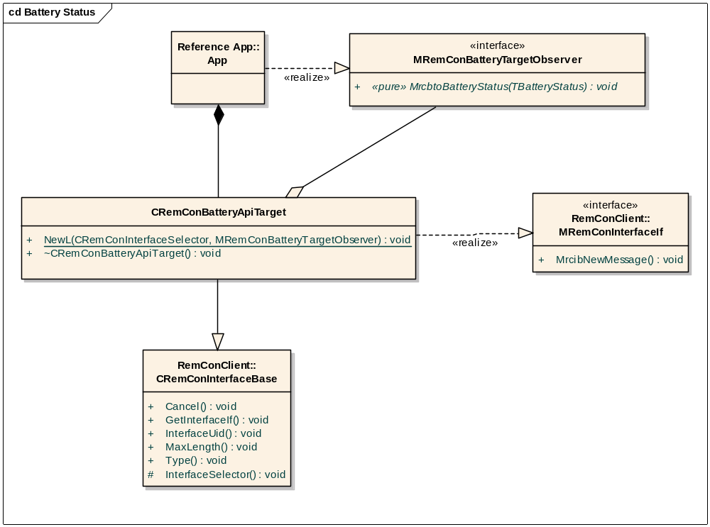
Figure 9 Battery Status API

Design Unit Behaviour
Again, this consists of a pair of classes. An M class is implemented by the client application and used by the interface class to inform the app of a new command. In this instance the purpose of the command is purely to inform the target of state on the controller. Although at a RemCon level a response is required a response from the client application is meaningless, as it is not mandated to act on the information anyway. For this reason a response function is not provided. Instead the interface class will respond to RemCon internally. This is illustrated in Figure 10 Inform Battery Status.
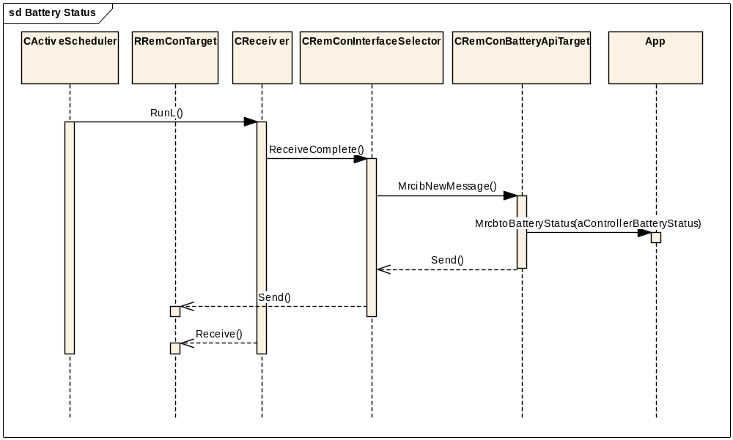
Figure 10 Inform Battery Status

Target Selector Plugin
The target selector plugin is an existing component in the RemCon system. This is responsible for addressing incoming commands to one or more target applications, addressing outgoing commands on connectionless sessions, and permitting or denying commands on connection oriented sessions. In the current RemCon although the TSP is able to route a single incoming command to multiple target sessions, but the handling of the multiple responses is not deterministic. This deficiency will be rectified as part of the work being done to handle AVRCP 1.3 commands.

Overview
To enable the response selection functionality the TSP interface will be extended. This is possible in a backwards compatible fashion using the existing extension mechanism.

UML Diagram
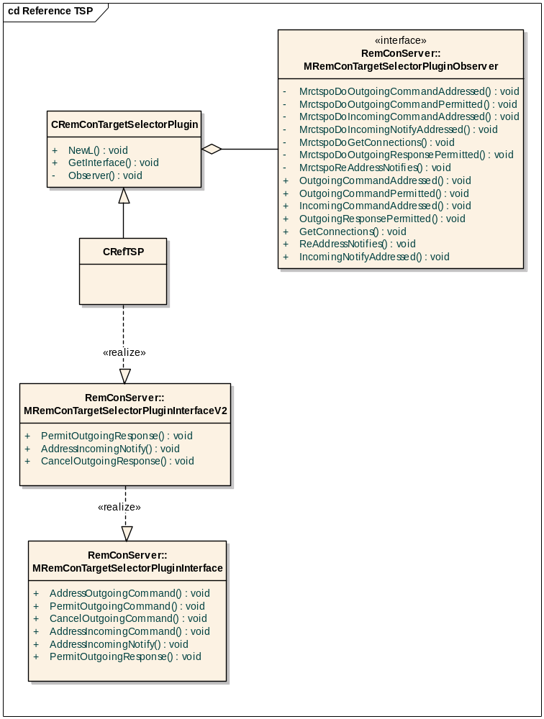
Figure 11 TSP

Design Unit Behaviour

Response Handling
RemCon allows a TSP to address an incoming command to multiple target applications. However, the current APIs do not provide deterministic handling of responses.
The API changes allow the TSP to choose which response to return to the bearer where multiple target applications have been addressed. When the TSP addresses a command RemCon will remember which target applications were addressed and are expected to respond. On receiving a response from a target application RemCon will ask the TSP whether that response should be returned to the bearer. To enable the TSP to make this decision it is provided with the TClientInfo of the client returning the response and a list of all clients still expected to respond. On being offered the response via the PermitOutgoingResponse function the TSP must return whether that response is accepted or rejected. Once one response has been accepted RemCon will offer no further responses to the TSP. For an example of this sequence see Figure 12 Multi-response handling. For more detail of how RemCon handles this see 3.4.3.1.
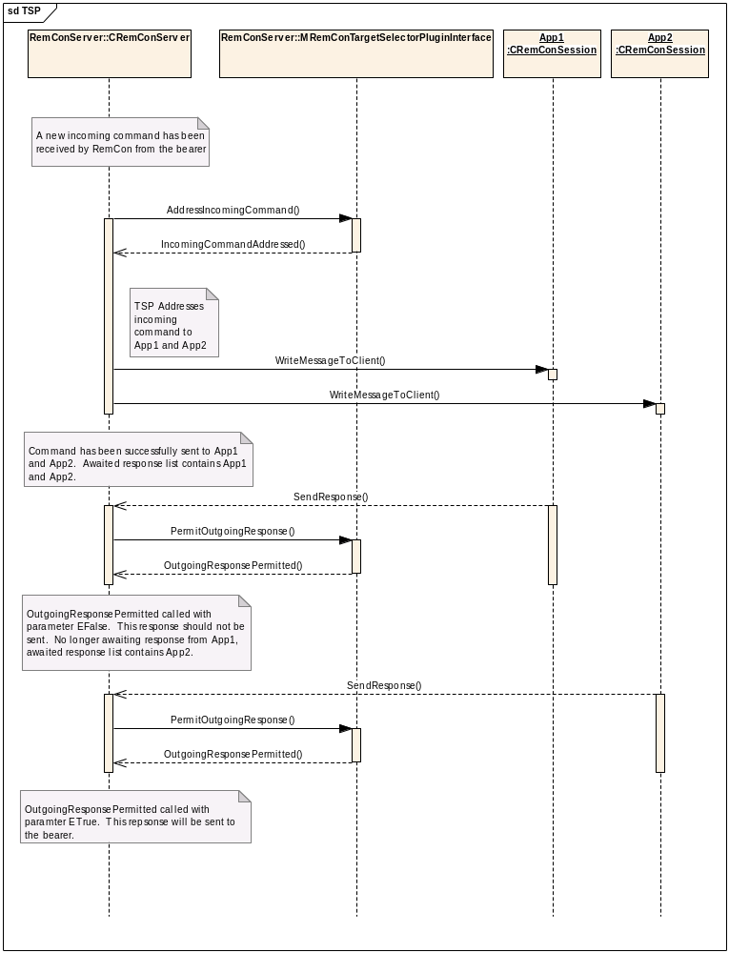
Figure 12 Multi-response handling

System State Change Handling
AVRCP 1.3 introduces long-running Notify commands. In 1.0 a command was addressed and responded to immediately. However, with Notify commands the system may need to switch player before a final response. For example if a remote device registers a notification on track change while the user is using their mp3 player then it may happen that the user switches to an alternative media player. In this case the remote device is now interested in when the track changes on the new (active) media player.
This sort of system state change is not visible to RemCon. The TSP though is best placed to know about this sort of change as it must know which media player is considered active to decide where to route newly received commands. For this reason a new function is added to the MRemConTargetSelectorPluginInterface to allow the TSP to inform RemCon when system state has change. This function is ReAddressNotifys. When the TSP calls this method RemCon will request addressing of each outstanding Notify. The readdressing occurs in the same way as the original addressing, via the AddressIncomingNotify command.

Notify Addressing
The addressing of Notify commands has one difference from other incoming commands. A Notify command may only be addressed to one media player. This is because the concept of a notification really only applies to one player. This should be the player to which the TSP is routing control commands, such as play. Restricting Notifies to one target application both simplifies the handling of notifies internally and provides compatibility with AVRCP 1.4, which introduces player addressing. For addressing of Notifies two new functions have been added, AddressIncomingNotify on the TSP interface and IncomingNotifyAddressed on the RemCon interface. These work in the same way as the existing command addressing, but with the change that only one target may be selected.
In the same way that AddressIncomingCommand requests are serialised AddressIncomingNotify requests are serialised. However, these occur independently, that is an AddressIncomingNotify request may be made on the TSP whilst an AddressIncomingCommand request is in progress.

AVRCP bearer
The AVRCP bearer is a RemCon bearer plugin, converting between AVRCP commands and RemCon interfaces. It currently supports the Core API, the Status API and and other APIs which are supported by extensions using the RemCon converter plugin mechanism.

Overview
There are two main changes required in the AVRCP bearer, the parsing of the Metadata Transfer commands and the addition of the fragmentation support required for AVRCP 1.3.
A change is also required to support notification from RemCon that a command will not receive a response from RemCon, for instance in the situation where the TSP has not addressed a command to any target, or the target application disconnects from RemCon before sending a response.

UML Diagram
Refer to AVRCP design document [R5].

Design Unit Behaviour
AVRCP 1.3 command parsing will be added into the existing command parsing structure.

RemCon Server

Overview
The AVRCP 1.3 introduces AV/C Notify commands which were not present in the original version of the spec. These commands have two responses, an interim response with the current state, and a second, final response when the state has changed. RemCon does not currently handle more than one response per target session per command so changes are necessary to enable this.
One way to do this is to split the Notify command into two RemCon commands inside the bearer. This could take place immediately on reception. This strategy would require handling of the error condition where the interim response does not succeed. A second option would be to create the command for the final response only once the response to the interim command has been successfully received. This would require that target application state is pushed to the client API to avoid race conditions where the target application state changes between the interim and final commands. However, splitting the command within the bearer has additional problems. The active player, that is the player that the CT intends to observe with the Notify command, may change between the interim and final response. In addition Notify commands should only be addressed to one target application. This implies that RemCon needs at least some knowledge of Notifies. For this reason Notify handling is added to RemCon. Note that as this is only needed for AVRCP currently the RemCon support is for the target role only.

UML Diagram
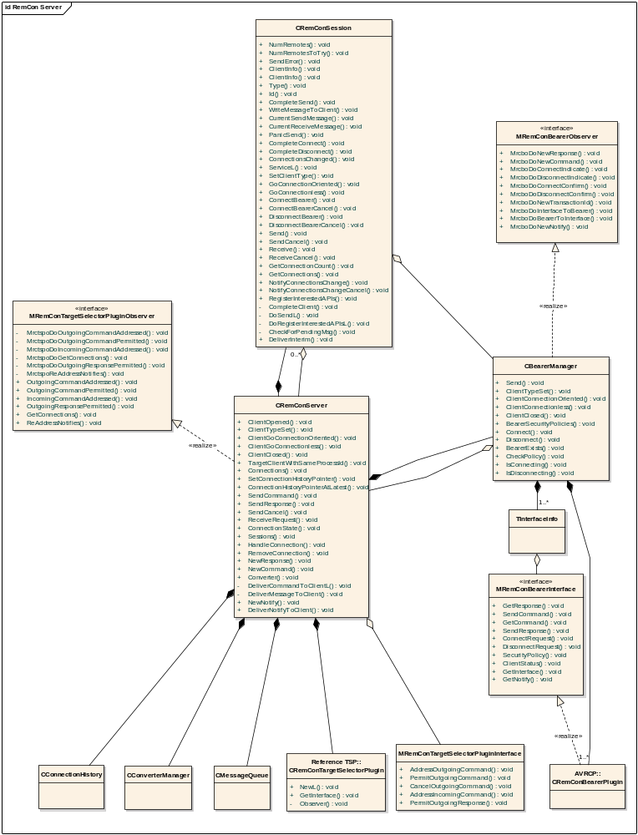
Figure 13 RemCon Server

Design Unit Behaviour
For current information about the workings of RemCon refer to the RemCon design document [R4]. How a basic incoming command is handled is illustrated in Figure 14 RemCon handling of command.

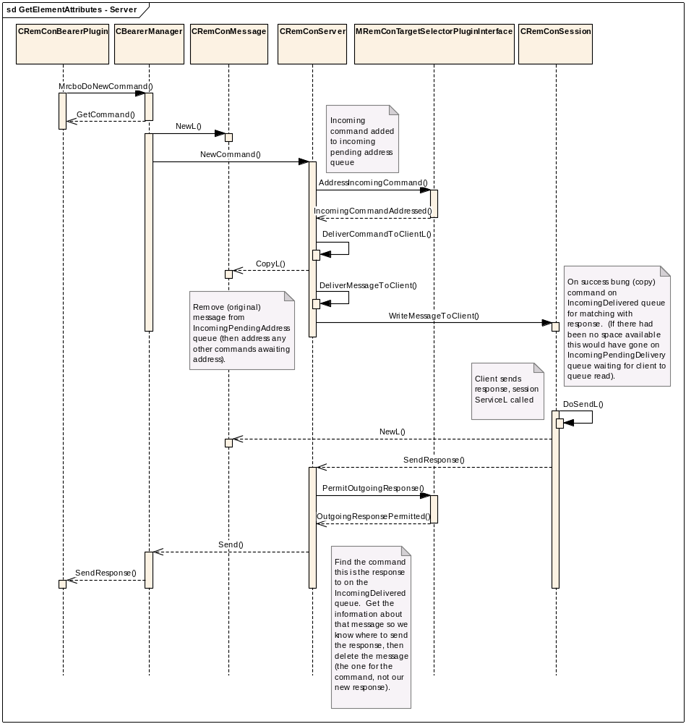
Figure 14 RemCon handling of command
This basic command handling sequence is similar to the previous version of RemCon.

Multiple Response Handling
After the TSP responds to an AddressIncomingCommand RemCon will store the list of clients to which the TSP has addressed the command (we expect each client to give some sort of response). This list is marked as “alive”, and keyed against the RemCon transaction ID of the command.
On receiving a response from one of the clients:
- If the list is “alive”, ask the TSP if this is the “canon” response by calling PermitOutgoingReponse, passing the client, and list of clients yet to respond.
- Remove this client from the list.
- If the response is “canon”, mark the list as “dead”, and forward the response to bearer, if it is not canon then discard
- If the list is “alive” and empty, inform bearer of error
- If the list is empty, delete it

On client disconnection:
- Remove the client from any response lists it is in
- If the list is “alive” and empty, inform bearer of error
- If the list is empty, delete it

This requires an addition to the bearer interface to allow an error to be returned to the bearer when a command cannot be successfully handled. If this is not implemented by a specific bearer then the behaviour will effectively be the same as when the TSP does not address a command to any client.

Notify Handling
Notifies are understood as a distinct command type by RemCon. They have different properties to standard control commands as they are long running and intended for one player. RemCon handles these, including re-addressing when system state changes.
For Notifies the entire information sent by the bearer is not sent to the client directly, but used by RemCon. For a notify the bearer will send a single Notify command to RemCon. This will be delivered to the server side session object notify manager (one per session). This will then make the appropriate requests on the client side. There are two possible calls RemCon may make on the client – request current state and start observing for state changes and request current state and do not start observing state.
For more information about this see use cases in section Error: Reference source not found and sequence diagrams below.
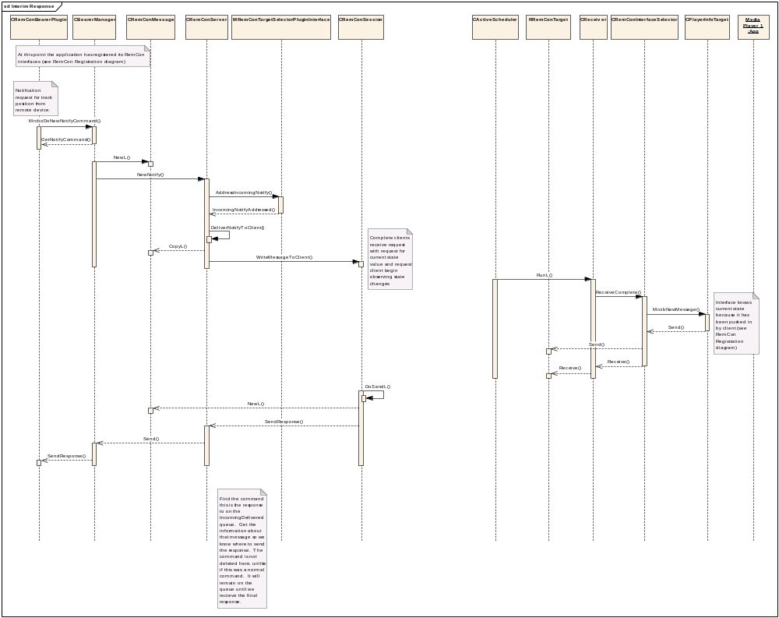
Figure 15 Interim

System State Change Handling
System state may change in a way not visible to RemCon (see section 3.2.3.2). When this occurs RemCon will request each outstanding notify is re-addressed.
In addition re-addressing will also be necessary when a new player opens a notification session on RemCon.

Design Considerations

Compatibility
The existing RemCon framework has been designed to allow future extensions, such as this work, to be made without impacting compatibility. Two main patterns are in use.

Exported Function Forwarding to Virtual Function
This involves each private pure virtual function on the class having an equivalent exported function. The exported function is what is used by the client and this just calls the virtual function. As the client is not using the virtual functions directly, additional functions can be added to the M class in the future without breaking BC on the client.
This pattern is used where the M class is intended for implementation within the Symbian code. It allows an interface to be extended without impacting the callers of that interface, however the implementers of the interface require update.
For an example of this pattern see MRemConTargetSelectorPluginObserver.

Interface Version Request
This involves requesting a specific version of an interface. It is implemented with a pair of classes, a C class which is instantiated and used to request an M class providing the required functionality. Before using the interface the client must call a GetInterface function passing in the ID of the requested version of the interface. If the requested version is not available an earlier version can be requested. This allows the client of an interface to use additional functionality where it is present, without requiring all implementers of that interface update to provide the new functionality.
This pattern is used where the M class is intended for implementation outside the Symbian code.
For an example of this pattern see MRemConTargetSelectorPluginInterface, and CRemConTargetSelectorPlugin.

Further Information

References
No. | Document Reference | Version | Description
[R1] | Audio/Video Remote Control Profile | 1.3 | The Bluetooth AVRCP specification
[R2] | 1394 Trade Association , AV/C Digital Interface Command Set – General Specification | 4.0
[R3] | 1394 Trade Association , AV/C Panel Subunit | 1.1
[R4] | Remote Control Design Document | 0.91
[R5] | AVRCP Design Document | 1.0

Open Issues

Glossary
Term | Definition

History
Version | Date | Change
1.0 | 18/9/08 | Released
0.52 | 30/10/07 | Accepted changes
0.51 | 10/10/07 | Add header file including MPlayerApplicationSettingsNotify and textual description
0.5 | 2/10/07 | Incorporate review comments from Tim
0.46 | 2/10/07 | Bolded new functionality in TSP API to make clear what is added
0.45 | 1/10/07 | Formatted following suggestions from Ian and removed Use Cases to separate document.
0.42 | 1/10/07 | Clarify that AddressIncomingNotify requests are serialised.
0.41 | 28/9/07 | Remove internal API header files, change TAttributeID to TMediaAttributeID, add history and change tracking
0.4 | 27/9/07 | First draft with public APIs for internal review
0.1 |  | First draft

